THE
POT
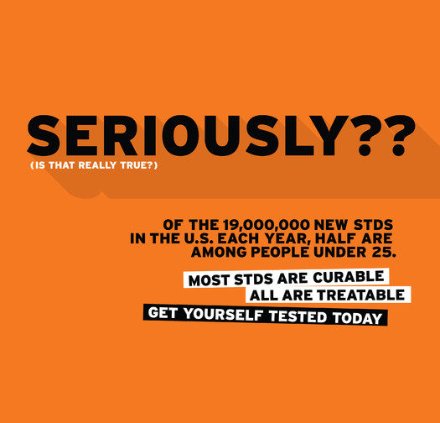
Get Yourself Tested
@ Scotlanes
Tues. 11/18 4-7pm

