**Valentine’s Day Grams!! (Sexy Edition)**

BJ Blast – cherry, strawberry, green apple

$2.50 per pack

Item Code: BJBLAST

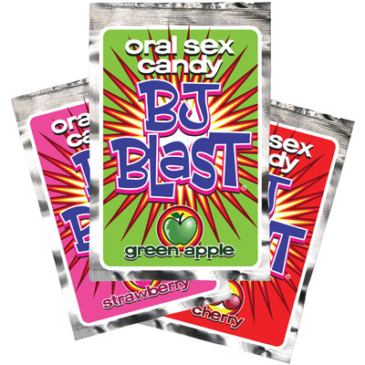

Lube – cherry, strawberry, watermelon, peach, tropical, plain water-based.

$7.50 per bottle

Item Code: LBOTTLE

OR

$1.25 for an individual use pack

Item Code: LPACKET

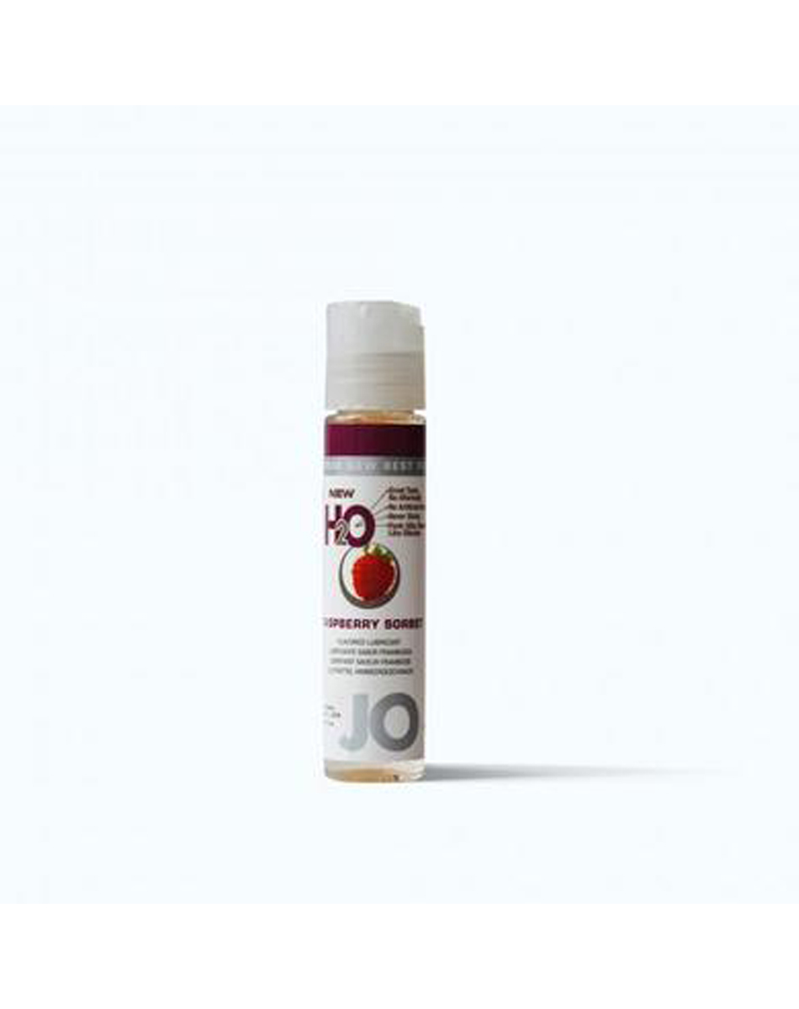

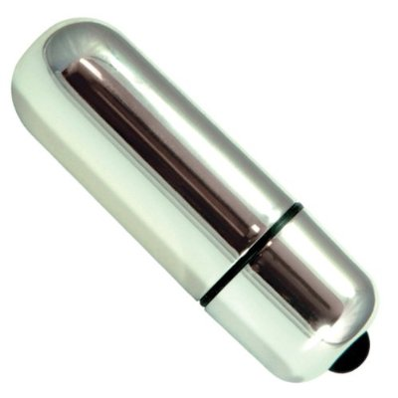

Small Vibrator – Colors may vary

$13.00 each

Item Code: VIBE

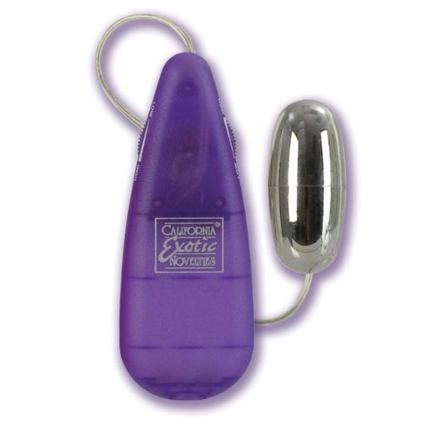

Magic Bullet – Colors may vary

$9.00 each

Item Code: BULLET

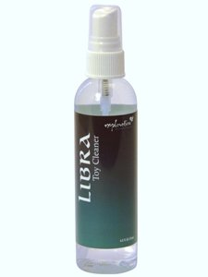

Toy Cleaner - Antibacterial spray-on cleanser gently cleans and disinfects surface bacteria, yet is mild enough to use after every session

$9.00 per bottle

Item Code: CLEAN

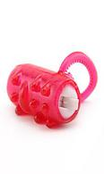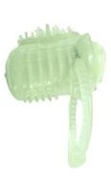

Oral Sex Tongue Vibrator – Colors may vary – Glow in the dark available

$8.00 each

ITEM CODE: ORALVIBE

Flavored Condoms – Flavors will vary

$1.00 each

ITEM CODE: SINGLEC

OR

$2.50 pack of 3

Item Code: PACK3

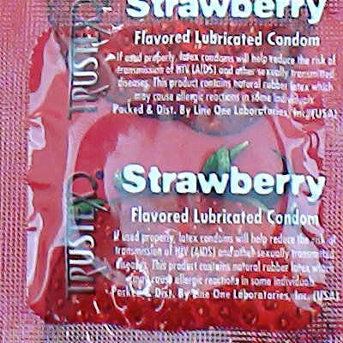

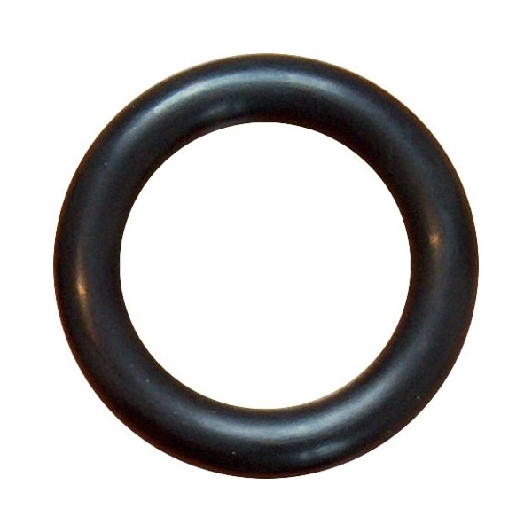

Rubber “Cock” Ring – One size fits all; Black only color option.

$2.50 each

Item Code: CRING

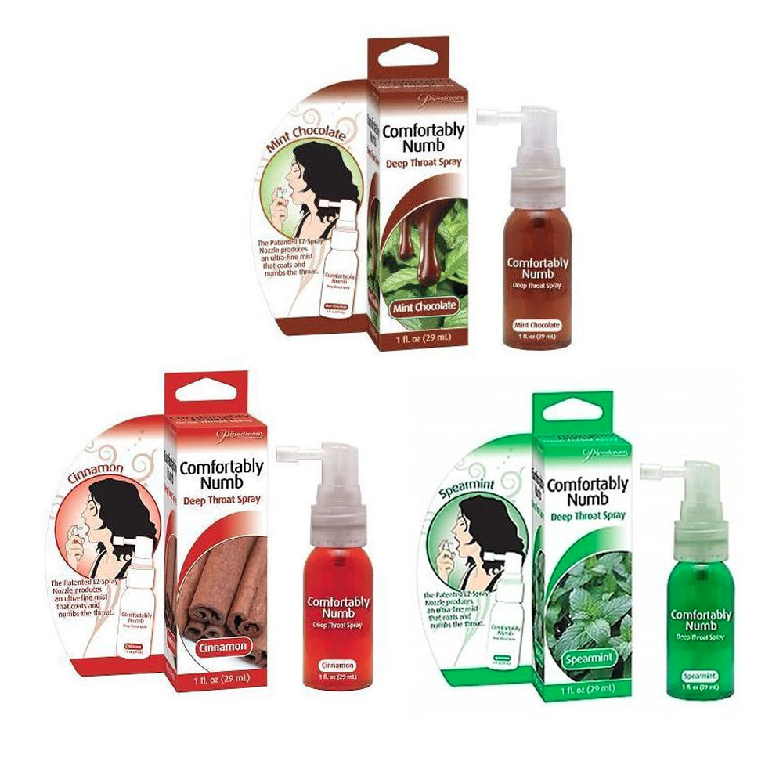

Comfortably Numb – Mint Chocolate, Spearmint, Cinnamon (availability of flavors may vary)

$10.00 per bottle

Item Code: CNUMB

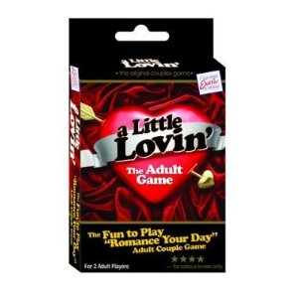

A Little Lovin’ Card Game - This game vaguely resembles euchre, with a trump color of 'A Little Lovin' card determining number of points won, these can be played on or discarded by your playmate. When either player has reached 50 points, they'll pick a Lovin' List card, which spells out sexy scenarios and situations.

$12.50 per deck

ITEM CODE: CARDS

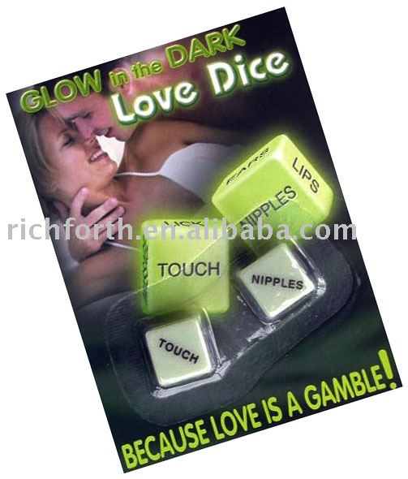

Glow in the dark Love Dice

$6.50 per deck

Item Code: DICE