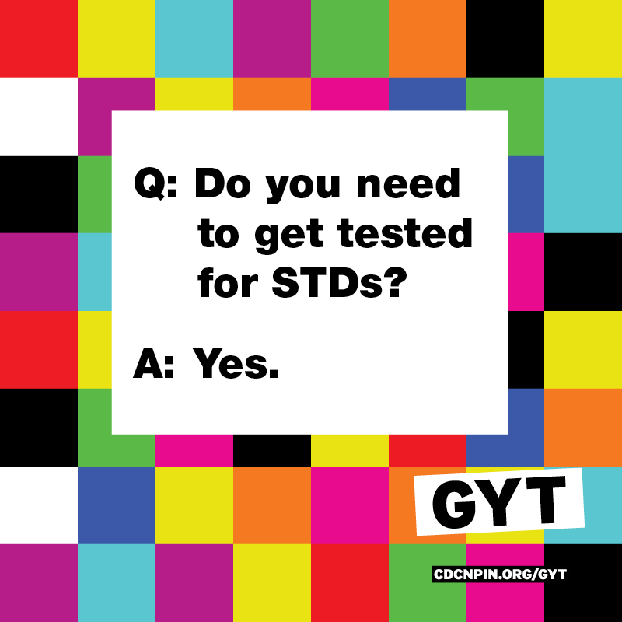

# **Free HIV/STI** testing will be available, along with **free food** catered by the Wooster Inn! The first 200 guests to show up will receive **a $5.00 gift card** to the Wooster Inn. Testing results will be held in confidence. Hosted by Wooster VOX, with the help of Planned Parenthood and the Wooster Inn.

* @Scotlanes
* 3:30-6:30pm

@woostervox || woostervox.tumblr.com

pinterest.com/woostervox || facebook.com/woostervox

A

P

R

I

L

2

2

### T

### U

### E S D A Y